Appendix A. Detection Methods for Non-Invasive Survey (NIS) Indicators
The Non-Invasive Survey (NIS) data used in this study were collected using standardized field instruments and laboratory protocols, each calibrated for specific analytes. The detection methods for each indicator are detailed below:
- Volatile Organic Compounds (VOCs) and Ammonia (NH₃)
Concentrations of VOCs and NH₃ were measured using the RAE Systems MultiRAE 2 (PGM-6280) portable gas detector (Fig.A1), equipped with a Photoionization Detector (PID). The PID operates by exposing gas molecules to ultraviolet (UV) light, inducing ionization and generating a measurable current proportional to the concentration of ionizable compounds. This sensor provides real-time, ppb-level sensitivity for a broad range of aromatic and aliphatic hydrocarbons commonly associated with petroleum leakage.
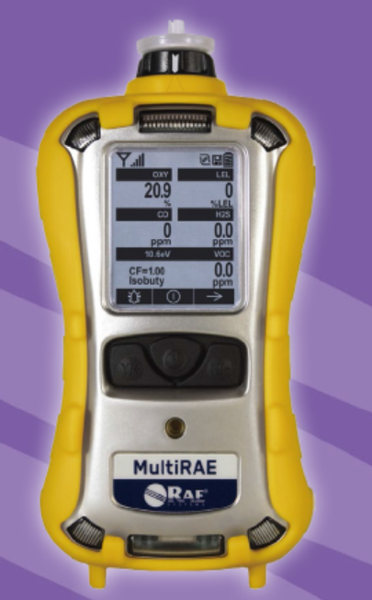
Fig.A1 Photograph of RAE Systems MultiRAE 2 (PGM-6280) portable gas detector.

- Carbon Dioxide (CO₂)
CO₂ concentrations were quantified using the NDIR (Non-Dispersive Infrared) sensor integrated into the MultiRAE 2 (Fig.A1). This method relies on the differential absorption of infrared radiation at specific wavelengths by CO₂ molecules. The degree of absorption is directly correlated with gas concentration, enabling accurate, drift-resistant measurements in ambient air.
- Hydrogen Sulfide (H₂S), Oxygen (O₂), and Formaldehyde (HCHO)
These gases were detected using electrochemical sensors within the MultiRAE 2 (Fig.A1). Each sensor contains a working electrode, counter electrode, and reference electrode immersed in an electrolyte. Target gases diffuse through a membrane and undergo oxidation or reduction reactions at the electrode surface, generating a current proportional to their concentration. These sensors offer high selectivity and low detection limits suitable for environmental monitoring.
- Methane (CH₄) and Hydrogen (H₂)
CH₄ and H₂, as combustible gases, were measured using catalytic bead (pellistor) sensors. These sensors operate on the principle of catalytic combustion: the target gas oxidizes on a heated catalyst surface, producing heat that changes the electrical resistance of a platinum wire coil embedded in the bead. The resistance change is calibrated to gas concentration and is particularly effective for detecting hydrocarbons and hydrogen in the lower explosive limit (LEL) range.
- Radon (²²²Rn)
Radon gas concentrations were measured using the Durridge RAD-7 digital alpha spectrometer (Fig.A2). This instrument employs a solid-state alpha-particle detector to capture and count alpha emissions from the decay of radon and its short-lived progeny (e.g., Po-218 and Po-214). The device samples air through a pump system, concentrates radon in a detection chamber, and quantifies its concentration in Bq/m³ based on the rate of alpha decays over a defined counting period.
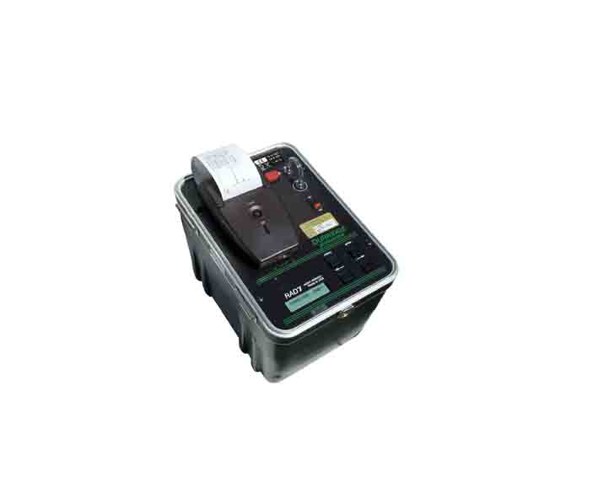
Fig.A2 Photograph of Durridge RAD-7 radon analyzer

- Functional Gene Abundance
The abundance of key functional genes involved in hydrocarbon degradation, specifically alkB and prmA, was quantified using quantitative PCR (qPCR) on the Thermo Fisher Scientific QuantStudio® 3 system (Fig.A3). Genomic DNA was extracted from soil samples, and target genes were amplified using species-specific primers. Gene copy numbers were calculated relative to a standard curve generated from known plasmid concentrations, and results were expressed as gene copies per gram of dry soil. This molecular approach provides direct, quantitative insight into the metabolic potential of indigenous microbial communities for hydrocarbon degradation.
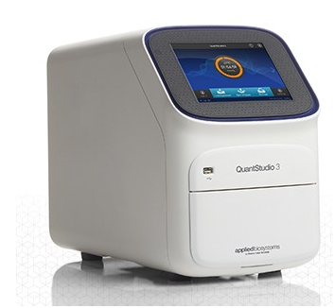
Fig.A3 Photograph of Thermo Fisher Scientific QuantStudio® 3 qPCR system
All instruments were calibrated prior to field deployment using certified reference gases and followed manufacturer-recommended protocols to ensure data accuracy and reproducibility.

